

**User Manual**

Created by Alex Salsali, Kelly Wang and Joanna Yang

**Table of Contents**

Pg. 3 - What is Bluebox?

* Introduction
* How to Play
* Basic Controls

Pg. 4 - Detailed operation

* Start Phase
* Question Phase
* Result Phase

Pg. 7 - Final Remarks

* Conclusion
* Contributions

**Introduction**

In the present day, recycling laws are quickly changing. As a result, consumers are being misinformed. To keep consumers updated, we are proud to introduce BlueBox, an app that allows consumers to check which items are recyclable in their region. BlueBox will prevent recycling fines and improve consumer knowledge. The user will answer a few simple questions about a certain item. Then, the app will return the item’s recycling information. To highlight, the app’s design allows the user to be more engaged and provides simple instructions for usage.

**How to Play**

Choose an object from the list given then click start to play. There will be a series of “Yes” or “No” questions that come up. Think about the properties of your chosen object and answer the questions by clicking the “Yes” or “No” buttons on the screen. There are also buttons to change your answer to the previous question and restart the game. When the application has figured out your object, it will display the object name on the screen with information on proper disposal of the object.

**Basic Controls**

BlueBox is very simple to use. The game’s controls are as follows:

* Start Button: Begin playing the game.
* Drop-Down Menu: A list of common household objects for you to choose from that BlueBox can identify.
* Yes/No Buttons: Answer questions that appear on screen about your object.
* Undo Button: Go back 1 question to change an answer.
* Restart Button: Go back to the first question during a current game or after the end screen.
* Save Picture Button: Take a snapshot of the end screen for your desired object and save it to your computer for future reference.

**How does BlueBox operate on the desktop?**

This manual will discuss the layout and function of BlueBox. The game is divided into three sections: the start phase, the question phase, and the result phase. There will be a brief description of each feature and its proper usage in order to enhance your experience.

**Start Phase**

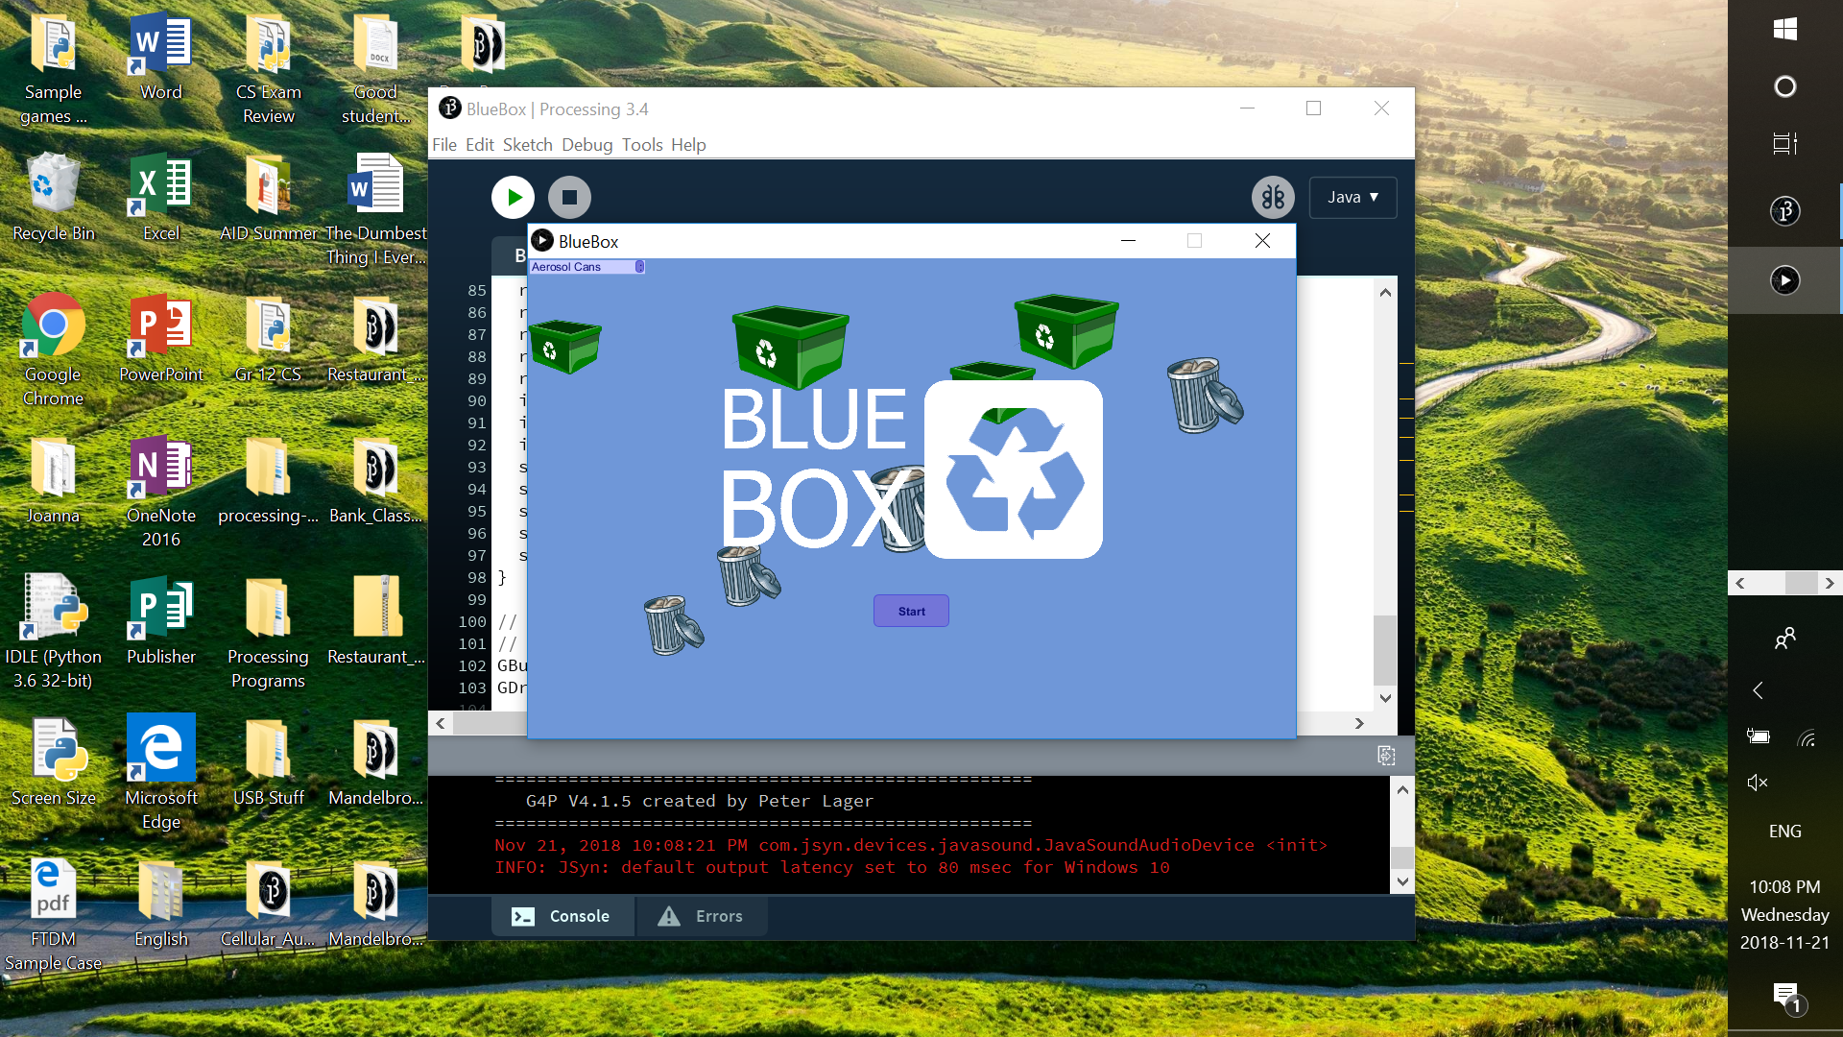

When you open BlueBox, you will see an animated background of colliding waste disposal bins, and hear “Put ‘em in the Blue” by Math Attack Schatt playing in the background.

You will see a drop-down menu of objects in the top left corner. Choose an object from the list and keep it in mind; it will also be displayed in the menu throughout the game. Click “Start” to begin the game.

**Question Phase**

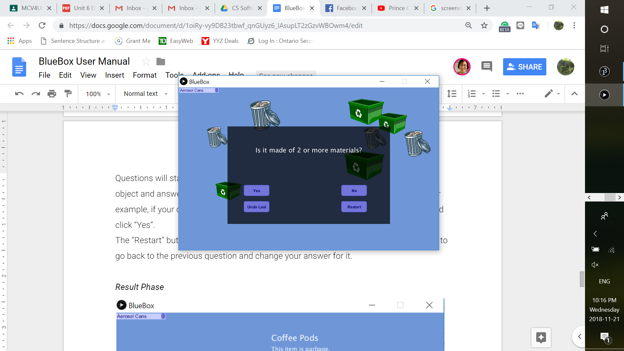

Questions will start to appear on the screen. Think about the properties of your chosen object and answer the questions by clicking “Yes” or “No”. For example, if your object is coffee pods and the question is “Is it made of 2 or more materials?”, you should click “Yes”.

Click “Restart” to go back to the first question. Click “Undo Last” to go back to the previous question and change your answer for it. Note that continuous undo is not supported; you may only go back one question. If you wish to go back further, please restart.

**Result Phase**

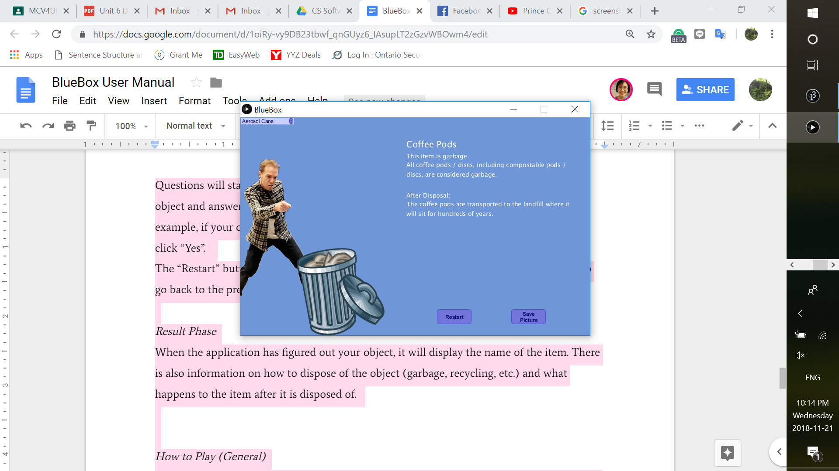

When BlueBox has figured out your object, it will progress to the end screen. It will display the name of your object, information on how to dispose of the object (garbage, recycling, etc.) and what happens to the object after disposal. Click “Restart” to learn about another object, or “Save Picture” to screenshot the info to your computer for future reference.

**Conclusion**

BlueBox informs about disposing of household objects in an effective manner. From the sound to the graphics, BlueBox proves to be a valuable application in everyday sustainable living. For additional information on BlueBox, contact our lead developers.

**Bibliography**

The BlueBox team thanks the CEO for his continuous advocacy for recycling and sustainable living, and for the opportunity to release this product. At this time, we also would like to recognize the efforts of everybody who helped develop Bluebox:

* Math Attack Schatt: Backing Soundtrack
* Misha Melnyk: Beta Tester/Advisor
* Danielle Wang: Beta Tester/Advisor
* Hadi Baghdadi: Beta Tester
* Nathan Lawson: Beta Tester